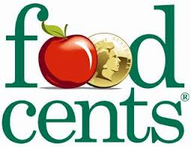FOODcents shows us anew way to balance our diet and food budget.

FOODcents can help you shop for and prepare tasty and healthy foods on a budget, which are quick and easy to make.

FOODcents highlights ways to buy more food for your dollar, and shows how to get better value for your money. It doesn’t cost more to eat good food for good health.

[](http://www.redcross.org.au/default.aspx)

**<http://www.foodcentsprogram.com.au/>**

Online training is free and relatively quick, you then have access to all the training resources, recipes, etc.

[**http://www.foodcentsprogram.com.au/training/**](http://www.foodcentsprogram.com.au/training/)